## Testing and Evaluation

Trader Interface

# Table of Contents

**Log In………………………………………………………………………………………………………………………. 2-3**

**Email verification…………………………………………………………………………………………………….. 4-6**

**Dashboard……………………………………………………………………………………………………………….. 6-14**

* **Shop………………………………………………………………………………………………………………… 6-10**
* **Product……………………………………………………………………………………………………………. 10-13**
* **Category………………………………………………………………………………………………………….. 13**
* **User…………………………………………………………………………………………………………………. 14**

**Log Out…………………………………………………………………………………………………………………….. 15**

# Log In

1. **Log in with empty fields**

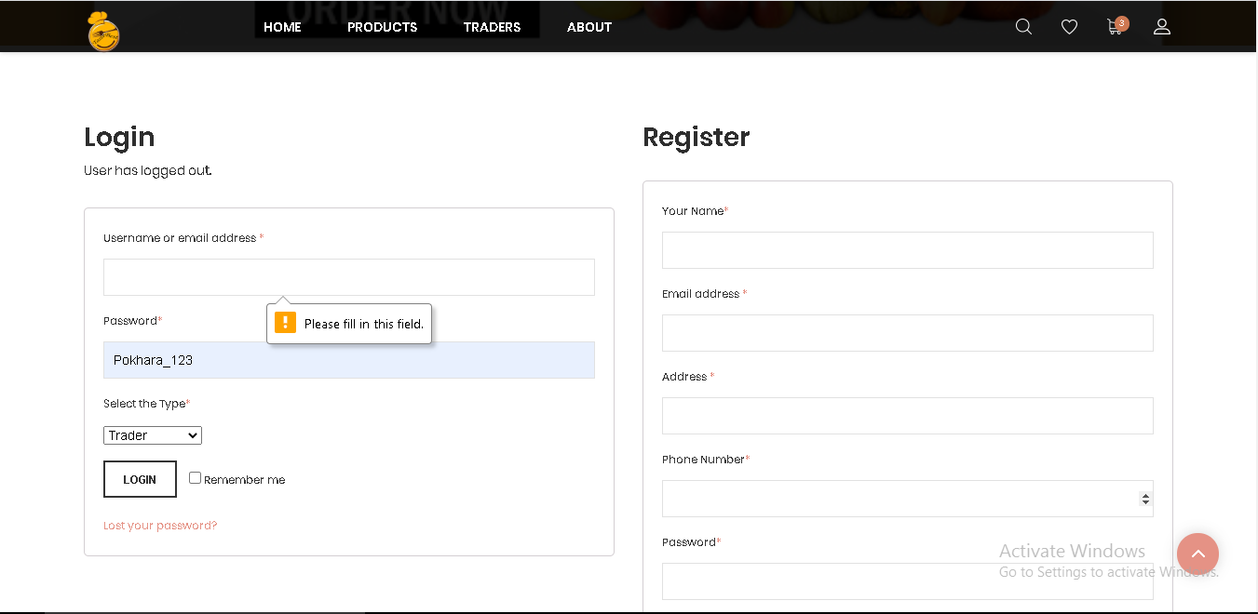

“Please fill in this field” message is displayed

1. **Log in with Invalid username**

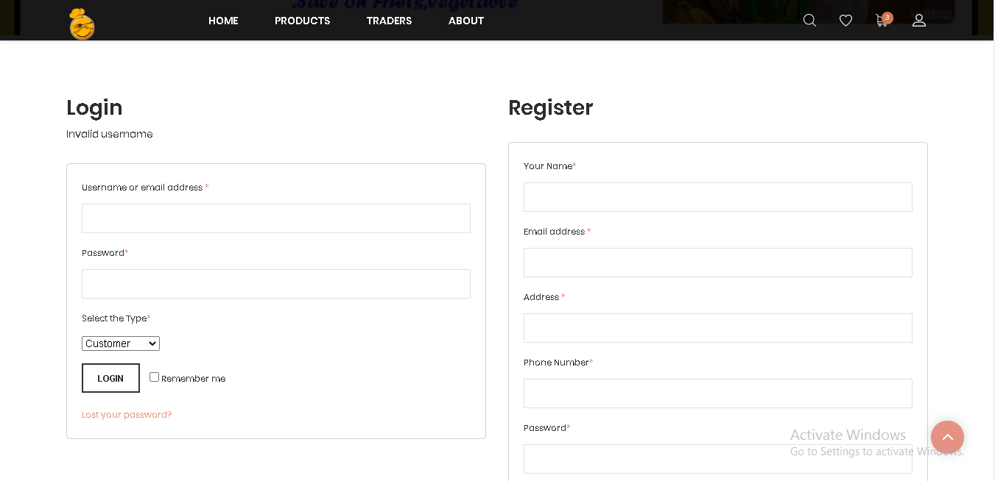

“Invalid Username” message is displayed

1. **Log in with invalid password**

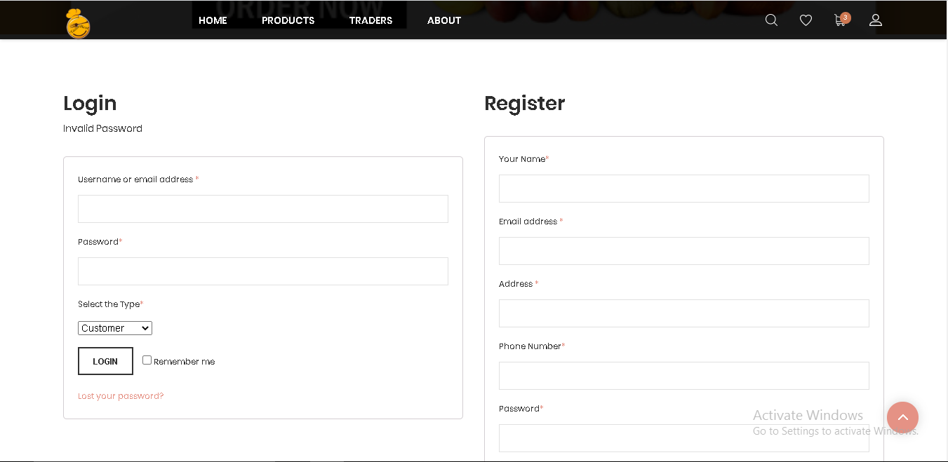

“Invalid Password” message is displayed

## E-mail verification

**Lost your password**

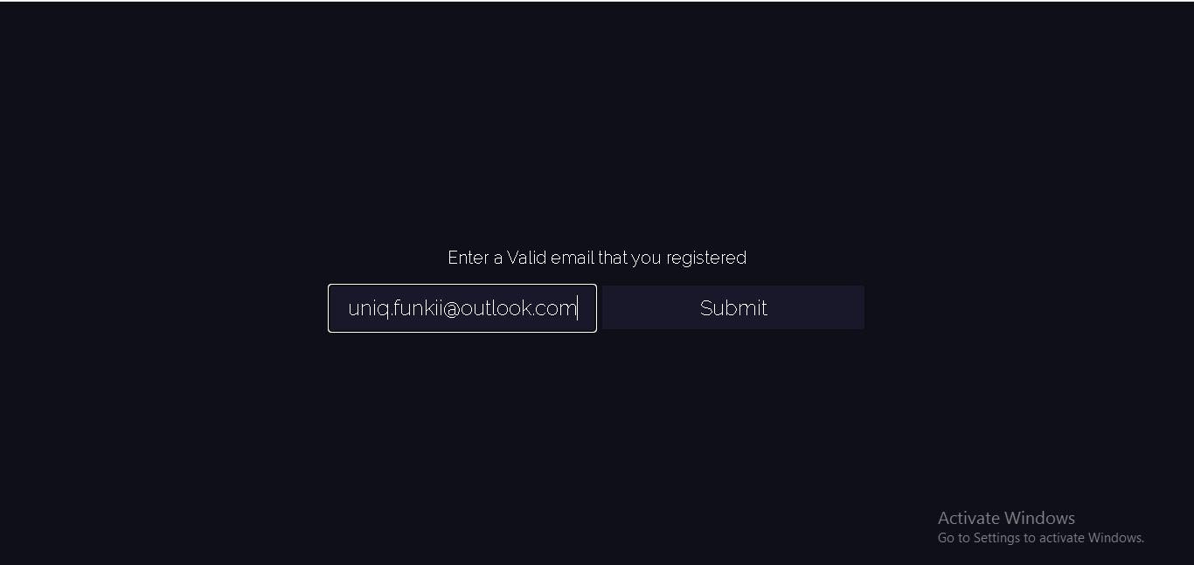

“Enter a valid email that you registered” message is displayed

**Invalid mail in lost password**

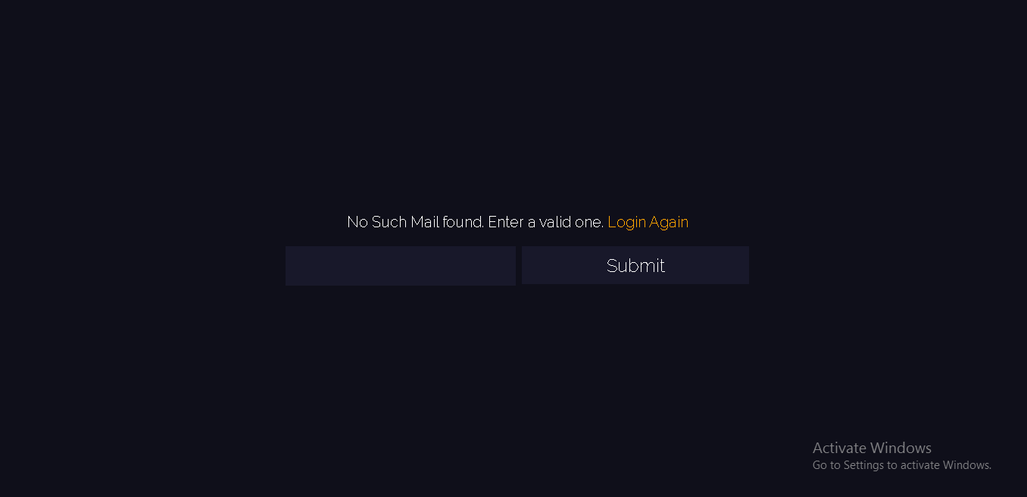

“No such email found. Enter a valid one. Login Again” message is displayed

**After writing email login again**

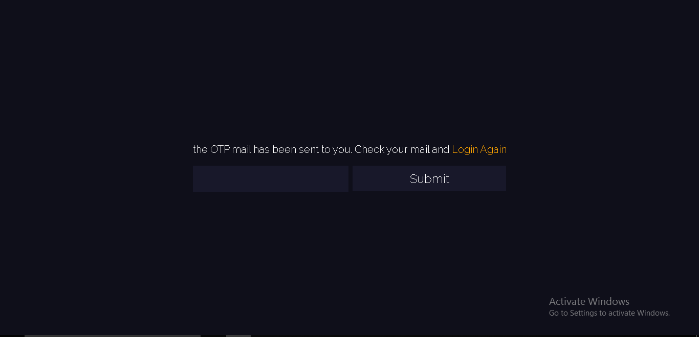

“The OTP mail has been sent to you. Check your email and Login Again” message is displayed

**Forget verification Otp**

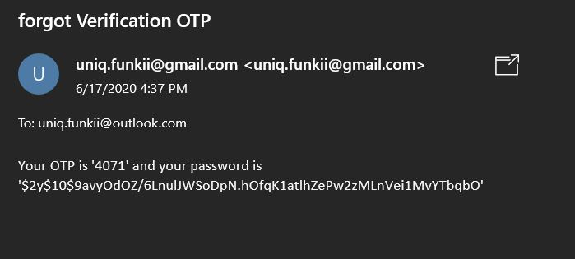

Forget verification otp has been sent to email

**Email verification Otp**

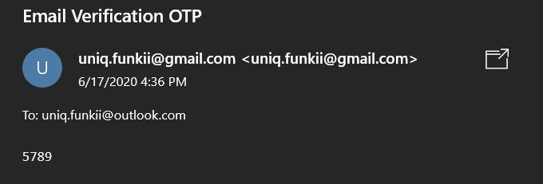

Email verification Otp has been sent

**After password recovery**

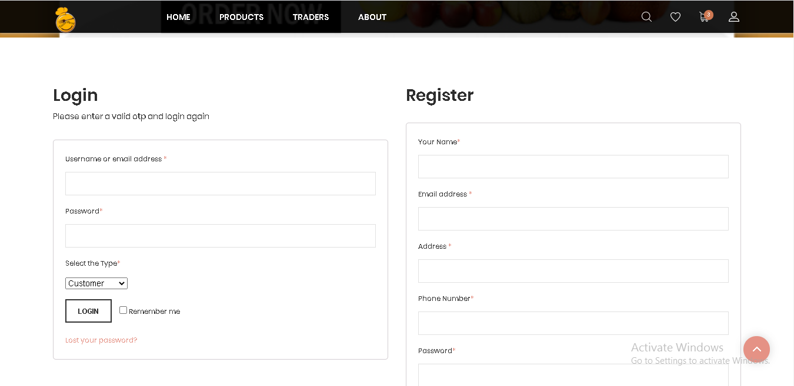

“Please enter a valid otp and login again” message is displayed

## Dashboard

# Shop

**View shop**

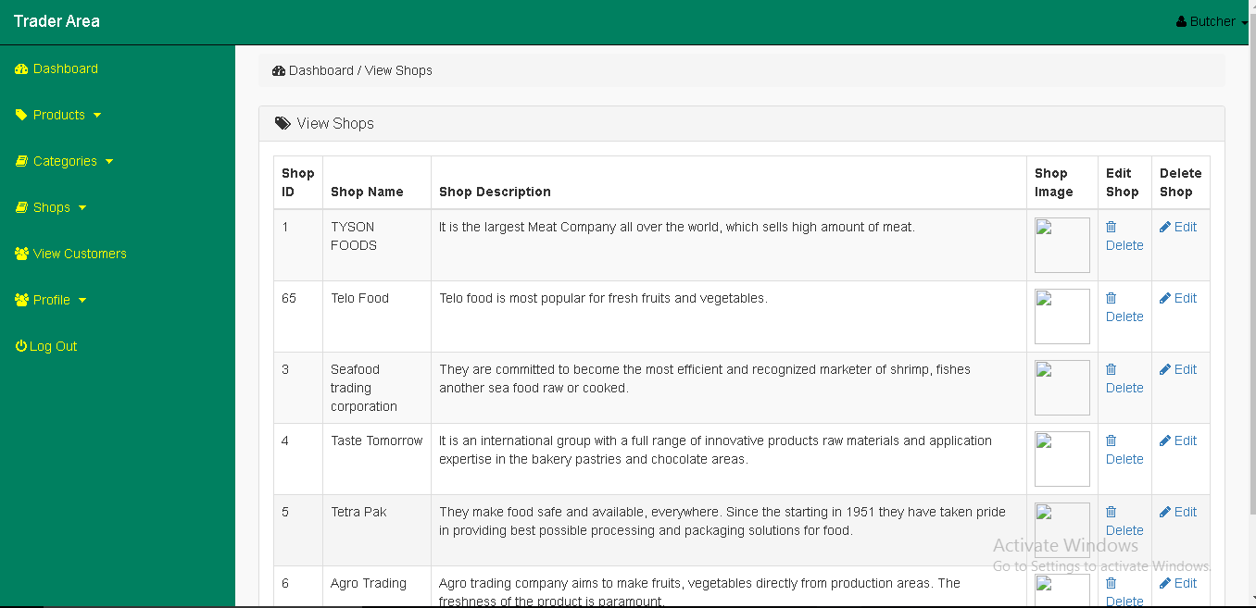

All the shop details with their profile is displayed

**Add shop with invalid fields**

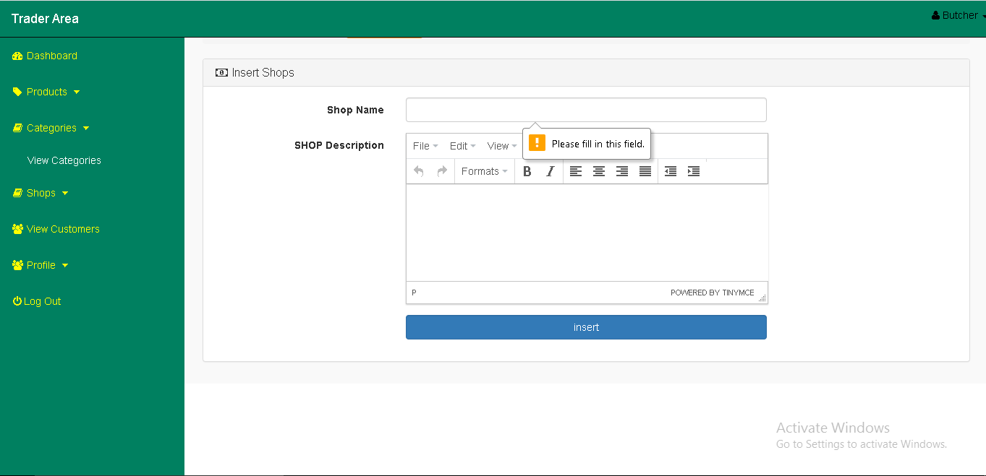

“Please fill in this field” message is displayed

**Insert shop**

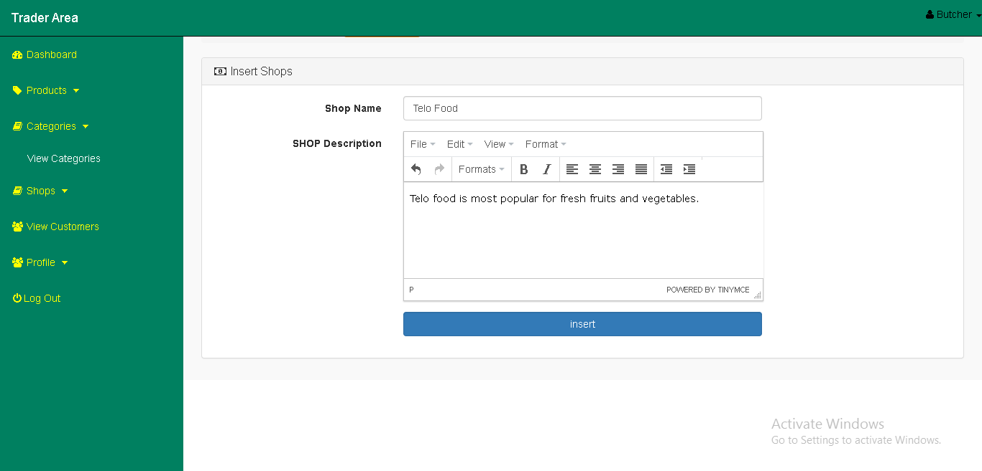

The given field has been filled

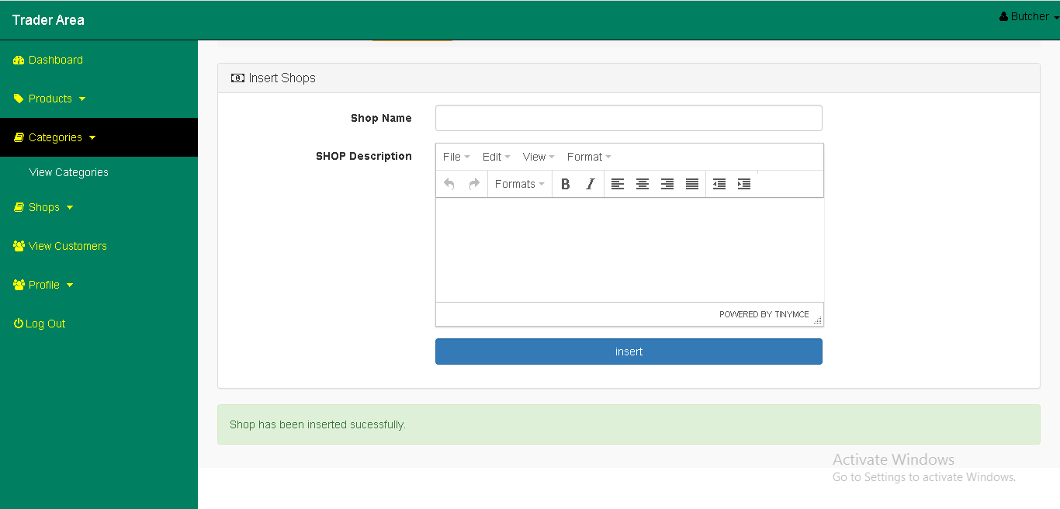

Shop has inserted to the database

**Update shop**

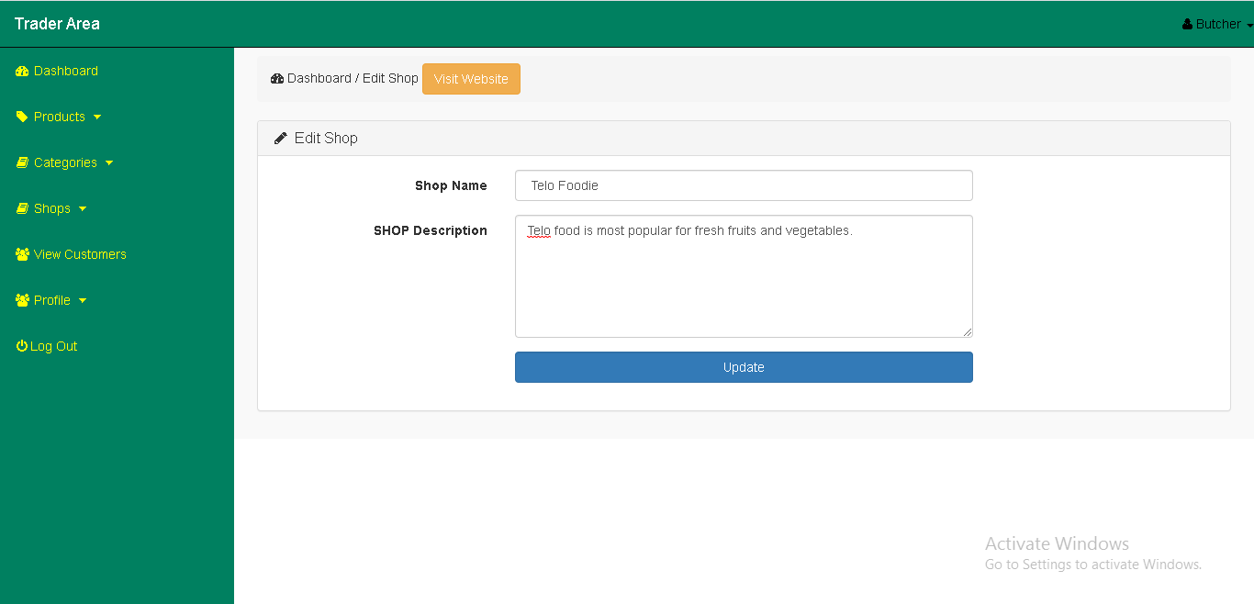

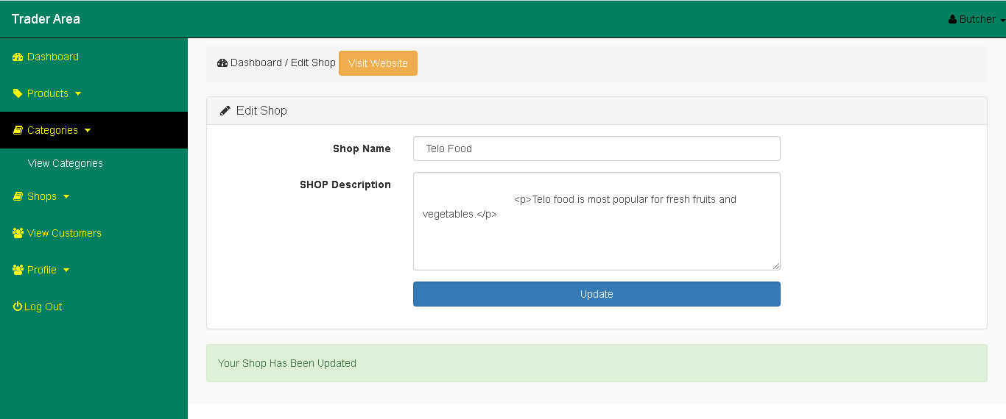

Shop has been updated successfully

**Delete shop**

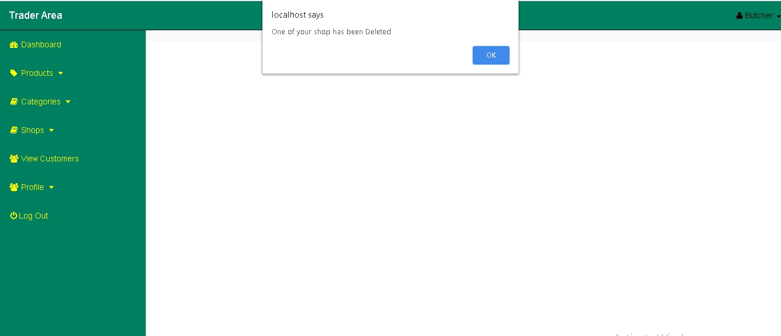

Selected shop has been deleted

# Product

1. **View Product**

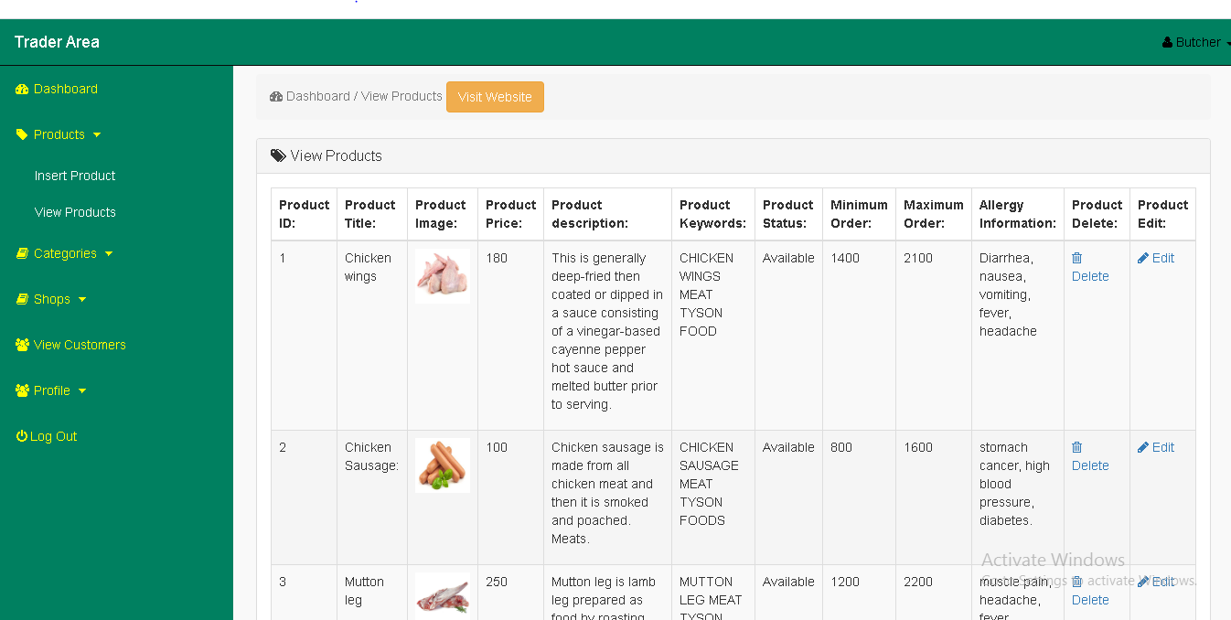

All products added by the trader will be displayed

**Add product with invalid field**

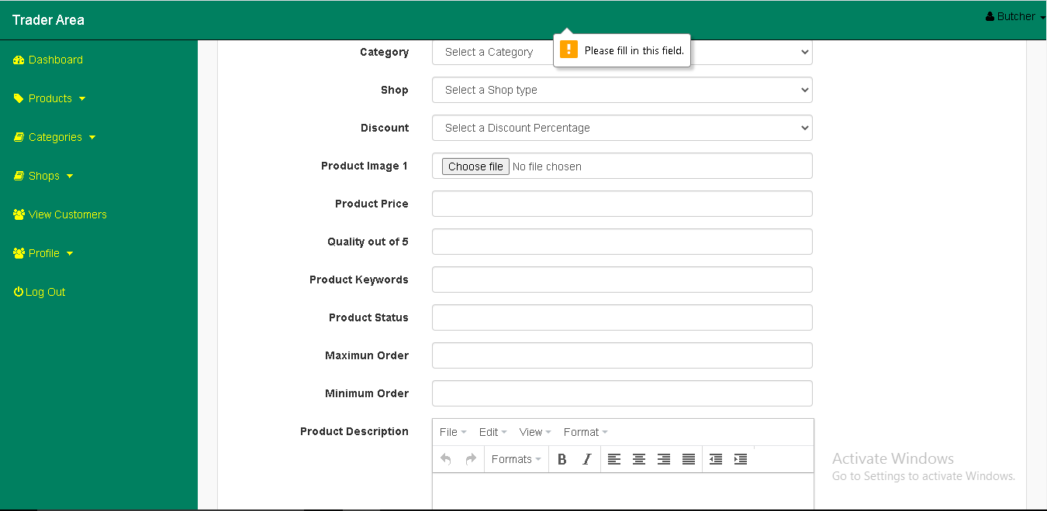

“Please fill in his field” message is displayed

1. **Update Product**

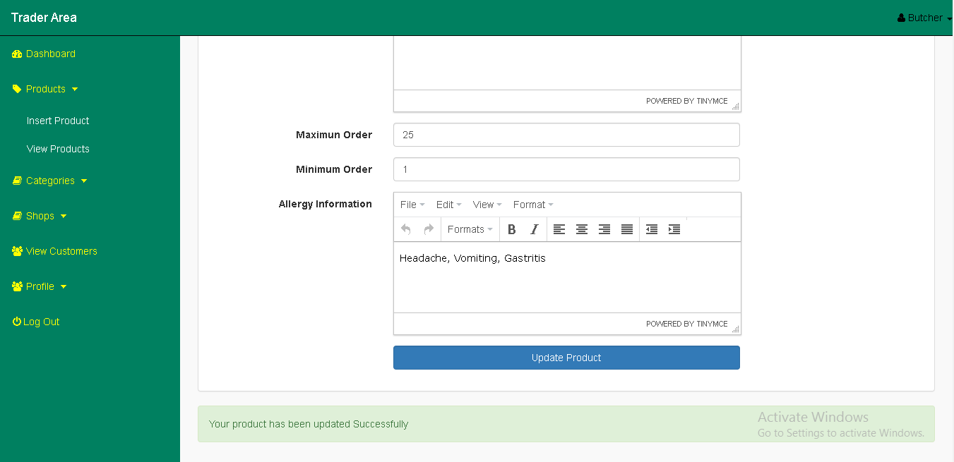

“Your product has been updated successfully” message is displayed

1. **Insert Product**

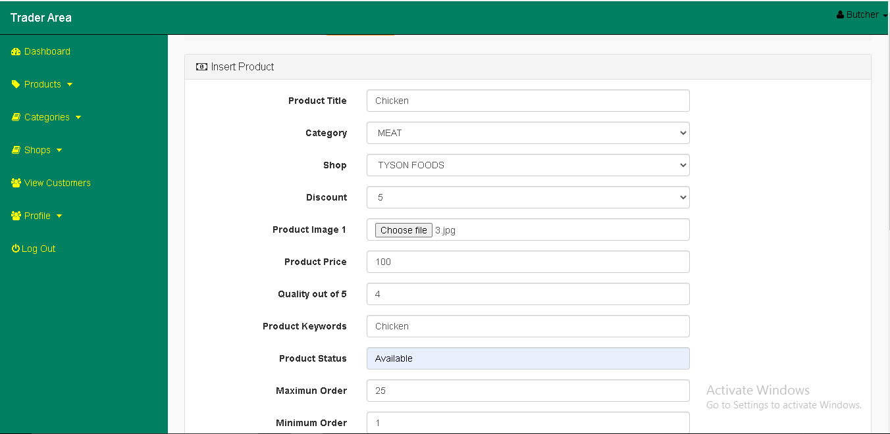

The given field has been filled

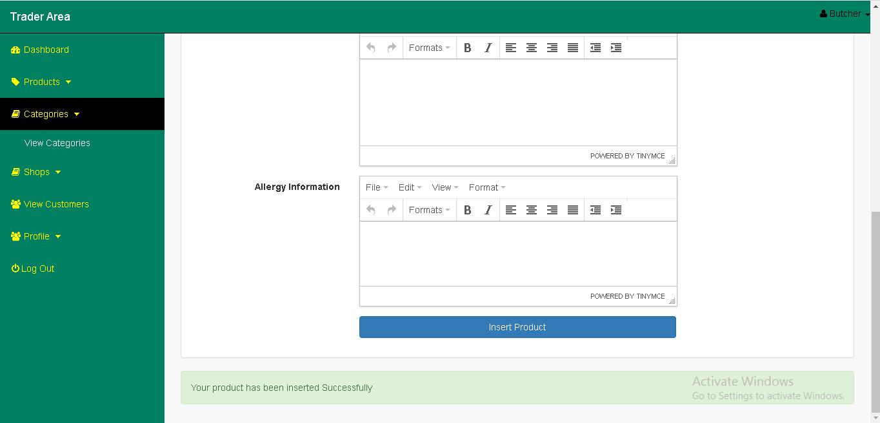

Product inserted to the database

1. **Delete product**

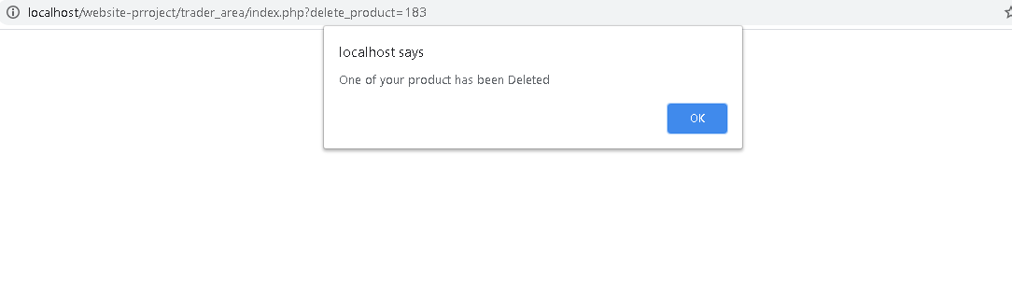

Selected Product deleted from database

# Category

**View Category**

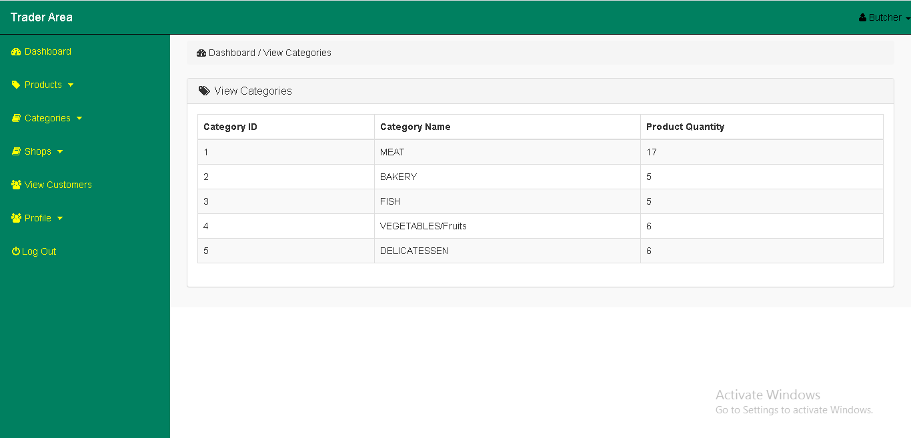

All the categories has been displayed

# User

**View user profile**

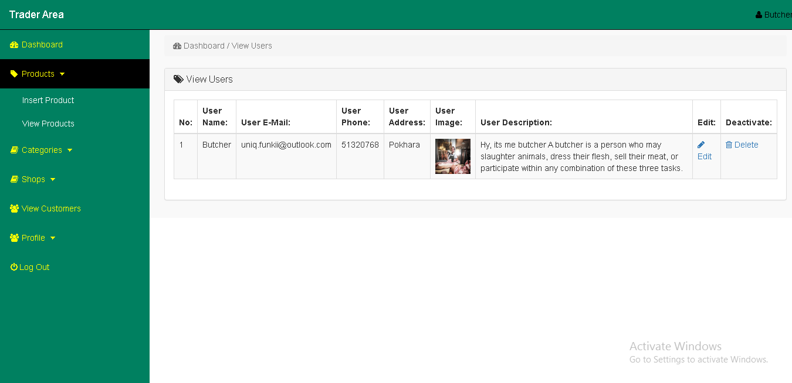

User profile has been displayed

**Update user**

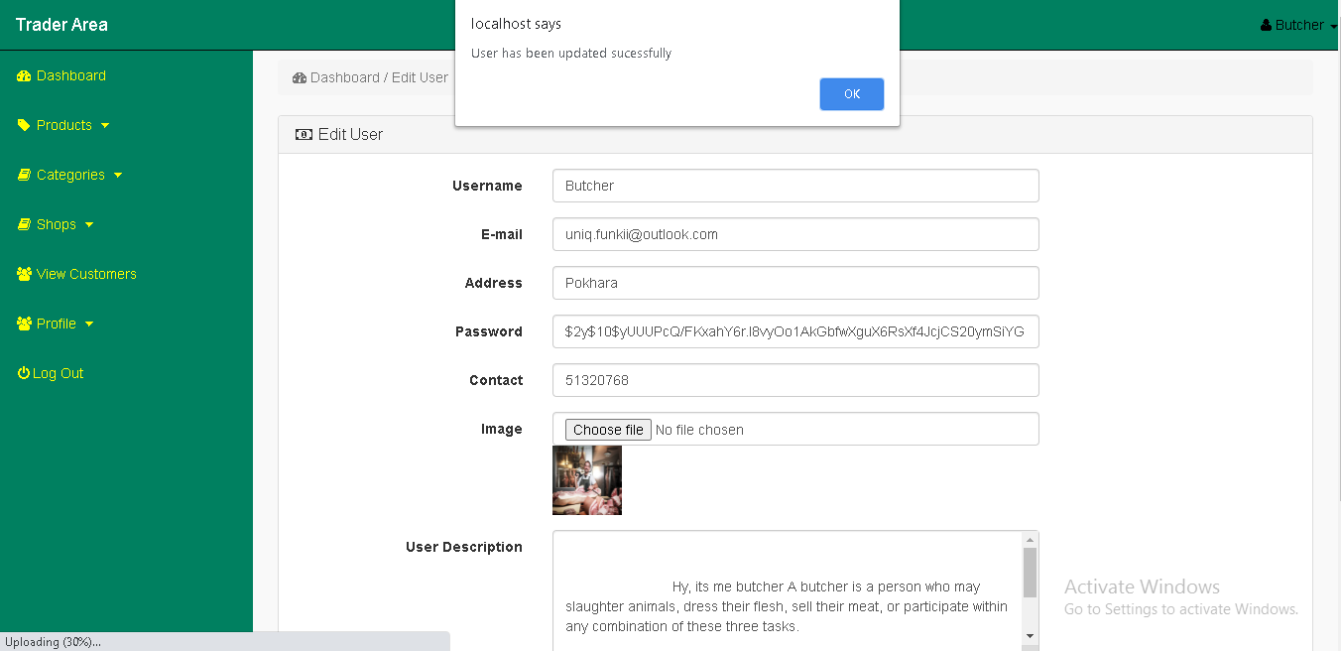

User has been updated successfully

# Log out

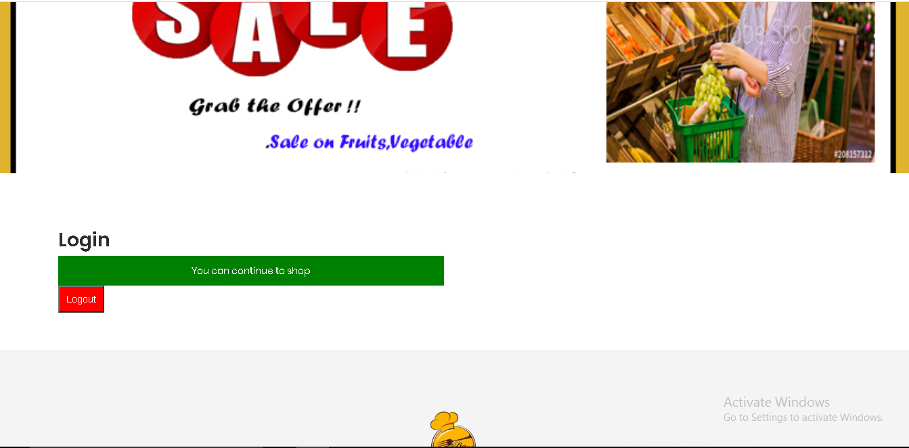

Trader logged out from the dashboard